# Output screenshot

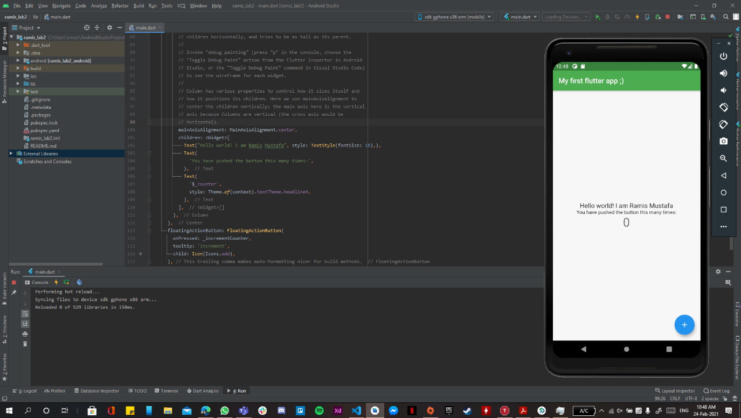

# Main.dart code

import 'package:flutter/material.dart';

*void* main() {

  runApp(*MyApp*());

}

class *MyApp* extends *StatelessWidget* {

  // This widget is the root of your application.

*@override*

*Widget* build(*BuildContext* context) {

    return *MaterialApp*(

      debugShowCheckedModeBanner: false,

      title: 'Flutter Demo',

      theme: *ThemeData*(

        primarySwatch: *Colors*.blue,

        visualDensity: *VisualDensity*.adaptivePlatformDensity,

      ),

      home: *MyHomePage*(title: 'My first flutter app ;)'),

    );

  }

}

class *MyHomePage* extends *StatefulWidget* {

*MyHomePage*({*Key* key, this.title}) : super(key: key);

  final *String* title;

*@override*

*_MyHomePageState* createState() => *_MyHomePageState*();

}

class *_MyHomePageState* extends *State*<*MyHomePage*> {

*int* _counter = 0;

*void* _incrementCounter() {

    setState(() {

      _counter++;

    });

  }

*@override*

*Widget* build(*BuildContext* context) {

    return *Scaffold*(

      appBar: *AppBar*(

        title: *Text*(widget.title),

        backgroundColor: *Colors*.green,

      ),

      body: *Center*(

        child: *Column*(

          mainAxisAlignment: *MainAxisAlignment*.center,

          children: <*Widget*>[

*Text*("Hello world! I am Ramis Mustafa", style: *TextStyle*(fontSize: 18),),

*Text*(

              'You have pushed the button this many times:',

            ),

*Text*(

              '$*_counter*',

              style: *Theme*.of(context).textTheme.headline4,

            ),

          ],

        ),

      ),

      floatingActionButton: *FloatingActionButton*(

        onPressed: _incrementCounter,

        tooltip: 'Increment',

        child: *Icon*(*Icons*.add),

      ), // This trailing comma makes auto-formatting nicer for build methods.

    );

  }

}

}